**EFS – Elastic File System**

Amazon Elastic File System (Amazon EFS) provides a simple, scalable, fully managed elastic NFS file system for use with AWS Cloud services and on-premises resources. It is built to scale on demand to petabytes without disrupting applications, growing and shrinking automatically as you add and remove files, eliminating the need to provision and manage capacity to accommodate growth

* Managed NFS (network file system) that can be mounted on many EC2
* EFS works with EC2 instances in multi-AZ
* Highly available, scalable, expensive (3x gp2), pay per use.
* Use cases: content management, web serving, data sharing, Wordpress
* Uses NFSv4.1 protocol
* Uses security group to control access to EFS
* Compatible with Linux based AMI (not Windows)
* Encryption at rest using KMS
* POSIX file system (~Linux) that has a standard file API
* File system scales automatically, pay-per-use, no capacity planning!
* Amazon EFS supports the Network File System version 4 (NFSv4.1 and NFSv4.0)
* An Amazon EFS file system can only have mount targets in one VPC at a time.

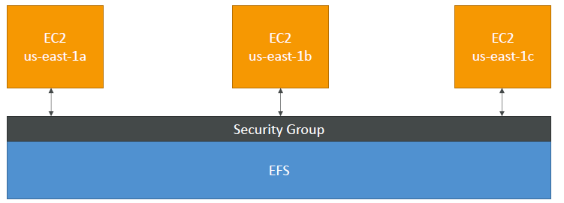

**EFS – Performance & Storage Classes**

EFS Scale

* 1000s of concurrent NFS clients, 10 GB+ /s throughput
* Grow to Petabyte-scale network file system, automatically

Performance mode (set at EFS creation time)

* General purpose (default): latency-sensitive use cases (web server, CMS, etc…)
* Max I/O – higher latency, throughput, highly parallel (big data, media processing)

Storage Tiers (lifecycle management feature – move file after N days)

* Standard: for frequently accessed files
* Infrequent access (EFS-IA): cost to retrieve files, lower price to store

**EFS Hands ON**

**Create NFS service**

Select vpc

Create mount target : select multiple AZ with security group

Enable Life cycle mgmt.:

* Automatically save up to 92% on your EFS bill as your access patterns change by enabling Lifecycle Management for your file system. Based on the policy you choose, any files in your file system that are not accessed for a period of time will automatically move to the EFS Infrequent Access (EFS IA) storage class.

Create file system

Step 2: Create Your two EC2 Resources in dif AZ and Launch Your EC2 Instance [you can attach the file system while creating ec2 insatnces as well]

Step 3: Attach security group in EC2 [Inound rules allow NFS protocol 2049]

Step 4: SSH into both EC2

Step 5: Install amazon efs utils package on both EC2

#sudo yum install -y amazon-efs-utils

Step 6: Mount your file system [any one instance]

#sudo mkdir efs

Mounting with encryption

# sudo mount -t efs -o tls fs-12345678:/ /efs

**EBS vs EFS – Elastic File System**

EBS volumes:

* can be attached to only one instance at a time
* are locked at the Availability Zone (AZ) level
* gp2: IO increases if the disk size increases
* io1: can increase IO independently

To migrate an EBS volume across AZ

* Take a snapshot
* Restore the snapshot to another AZ
* EBS snapshots require EBS backups which uses IO and you shouldn’t run them while your application is actively using EBS volume else you get performance issue.

Root EBS Volumes of instances get terminated by default if the EC2 instance [You can disable that]

* Mounting 100s of instances across AZ
* EFS share website files (WordPress)
* Only for Linux Instances (POSIX)
* EFS has a higher price point than EBS
* Can leverage EFS-IA for cost savings